SECTION 1: Identification

1.1. Identification
Product form | : | Mixture
Product name | : | Unicrete 60 Flowz-CO
CAS-No. | : | Mixture
Product code | : | 3298
Other means of identification | : | Alumina-Silicate Cement Bonded Castable

1.2. Recommended use and restrictions on use
Use of the substance/mixture | : | Refractory
Recommended use | : | Industrial use

1.3. Supplier
Resco Products, Inc.
One Robinson Plaza, Suite 300
6600 Steubenville Pike
Pittsburgh, PA 15205 - United States
412-494-4491
SDS@RescoProducts.com - WWW.RescoProducts.com

1.4. Emergency telephone number
Emergency number | : | EMERGENCY ONLY (CHEMTREC) USA & Canada 1-800-424-9300 Outside USA & Canada +1 703-741-5970

SECTION 2: Hazard(s) identification

2.1. Classification of the substance or mixture

GHS US classification
Skin corrosion/irritation Category 2 | H315 | Causes skin irritation
Serious eye damage/eye irritation Category 2B | H320 | Causes eye irritation
Carcinogenicity Category 1A | H350 | May cause cancer (Inhalation)
Full text of H statements : see section 16

2.2. GHS Label elements, including precautionary statements

GHS US labeling
Hazard pictograms (GHS US) | : | 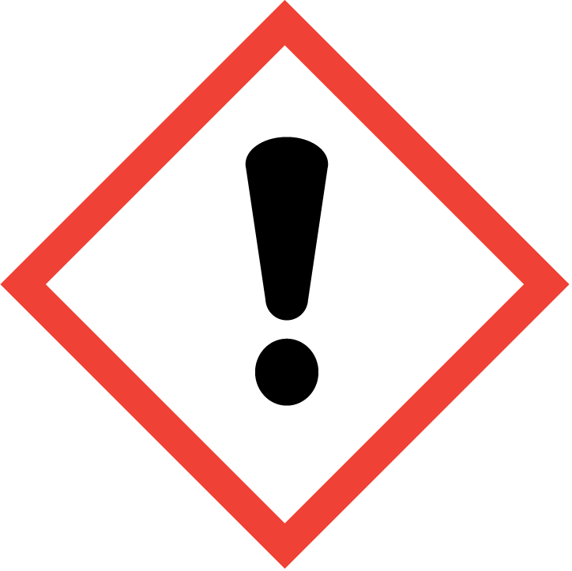 | 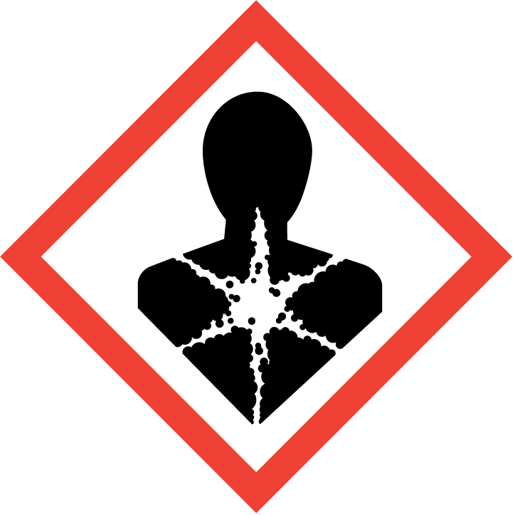
Signal word (GHS US) | : | Danger
Hazard statements (GHS US) | : | H315 - Causes skin irritation  H320 - Causes eye irritation  H350 - May cause cancer (Inhalation)
Precautionary statements (GHS US) | : | P280 - Wear eye protection, Dust respirator, protective gloves.  P305+P351+P338 - IF IN EYES: Rinse cautiously with water for several minutes. Remove contact lenses, if present and easy to do. Continue rinsing.  P332+P313 - If skin irritation occurs: Get medical advice/attention.  P337+P313 - If eye irritation persists: Get medical advice/attention.  P260 - Do not breathe dust.

2.3. Other hazards which do not result in classification
No additional information available

2.4. Unknown acute toxicity (GHS US)
Not applicable
SECTION 3: Composition/Information on ingredients

3.1. Substances
Not applicable

3.2. Mixtures

Name | Product identifier | % | GHS US classification
aluminium oxide, non-fibrous | (CAS-No.) 1344-28-1 | 10 – 20 | Not classified
Calcium Aluminate Cement | (CAS-No.) 65997-16-2 | 1 – 5 | Skin Irrit. 2, H315  Eye Irrit. 2B, H320
quartz | (CAS-No.) 14808-60-7 | 1 – 5 | Carc. 1A, H350
cristobalite | (CAS-No.) 14464-46-1 | 0.1 – 0.5 | Carc. 1A, H350

Full text of hazard classes and H-statements : see section 16

SECTION 4: First-aid measures

4.1. Description of first aid measures
First-aid measures general | : | Never give anything by mouth to an unconscious person. If you feel unwell, seek medical advice (show the label where possible).
First-aid measures after inhalation | : | Allow affected person to breathe fresh air. Allow the victim to rest.
First-aid measures after skin contact | : | Wash with plenty of soap and water. Wash contaminated clothing before reuse.
First-aid measures after eye contact | : | IF IN EYES: Rinse cautiously with water for several minutes. Remove contact lenses, if present and easy to do. Continue rinsing.
First-aid measures after ingestion | : | Rinse mouth. Do NOT induce vomiting. Obtain emergency medical attention.

4.2. Most important symptoms and effects (acute and delayed)
Potential Adverse human health effects and symptoms | : | Based on available data, the classification criteria are not met.
Symptoms/effects after inhalation | : | May cause cancer by inhalation. Danger of serious damage to health by prolonged exposure through inhalation.
Symptoms/effects after skin contact | : | Causes skin irritation.
Symptoms/effects after eye contact | : | Causes eye irritation.

4.3. Immediate medical attention and special treatment, if necessary
No additional information available

SECTION 5: Fire-fighting measures

5.1. Suitable (and unsuitable) extinguishing media
Suitable extinguishing media | : | Use extinguishing media appropriate for surrounding fire.
Unsuitable extinguishing media | : | In case of fire, all extinguishing media allowed.

5.2. Specific hazards arising from the chemical
Fire hazard | : | Not flammable.

5.3. Special protective equipment and precautions for fire-fighters
Firefighting instructions | : | Exercise caution when fighting any chemical fire. Prevent fire-fighting water from entering environment.
Protection during firefighting | : | Do not enter fire area without proper protective equipment, including respiratory protection.

SECTION 6: Accidental release measures

6.1. Personal precautions, protective equipment and emergency procedures

6.1.1. For non-emergency personnel
Emergency procedures | : | Do not breathe dust.
6.1.2. For emergency responders
Protective equipment | : | Equip cleanup crew with proper protection.
Emergency procedures | : | Ventilate area.

6.2. Environmental precautions
Prevent entry to sewers and public waters.

6.3. Methods and material for containment and cleaning up
Methods for cleaning up | : | On land, sweep or shovel into suitable containers. Minimize generation of dust.

6.4. Reference to other sections
See Heading 8. Exposure controls and personal protection.

SECTION 7: Handling and storage

7.1. Precautions for safe handling
Precautions for safe handling | : | Do not handle until all safety precautions have been read and understood. Avoid raising dust. Avoid contact with skin and eyes. Do not breathe dust.
Hygiene measures | : | Wash hands and other exposed areas with mild soap and water before eating, drinking or smoking and when leaving work.

7.2. Conditions for safe storage, including any incompatibilities
Storage conditions | : | Store this product in a dry location where it can be protected from the elements.
Incompatible products | : | Strong bases. Strong acids.

SECTION 8: Exposure controls/personal protection

8.1. Control parameters

Unicrete 60 Flowz-CO (Mixture)
No additional information available

Calcium Aluminate Cement (65997-16-2)
No additional information available

cristobalite (14464-46-1)
USA - ACGIH - Occupational Exposure Limits
ACGIH TWA (mg/m³) | 0.025 mg/m³ respirable dust
USA - OSHA - Occupational Exposure Limits
OSHA PEL (TWA) (mg/m³) | 0.05 mg/m³ respirable dust

aluminium oxide, non-fibrous (1344-28-1)
USA - ACGIH - Occupational Exposure Limits
ACGIH TWA (mg/m³) | 1 mg/m³ respirable dust

quartz (14808-60-7)
USA - ACGIH - Occupational Exposure Limits
ACGIH TWA (mg/m³) | 0.025 mg/m³ (Silica-Crystalline Quartz; USA; Time-weighted average exposure limit 8 h; TLV - Adopted Value; Respirable fraction)
USA - OSHA - Occupational Exposure Limits
Local name | Silica, crystalline quartz, respirable dust
OSHA PEL (TWA) (mg/m³) | 0.05 mg/m³ respirable dust
Remark (OSHA) | (3) See Table Z-3.

8.2. Appropriate engineering controls
Appropriate engineering controls | : | Provide adequate ventilation to minimize dust concentrations.
8.3. Individual protection measures/Personal protective equipment
Personal protective equipment:
Avoid all unnecessary exposure.

Hand protection:
Wear protective gloves.

Eye protection:
Chemical goggles or safety glasses

Skin and body protection:
Wear suitable protective clothing

Respiratory protection:
Wear appropriate mask

Other information:
Do not eat, drink or smoke during use.

SECTION 9: Physical and chemical properties

9.1. Information on basic physical and chemical properties
Physical state | : | Solid
Appearance | : | Granular mixture.
Color | : | Gray
Odor | : | None
Odor threshold | : | Not applicable
pH | : | No data available
Melting point | : | > 3000 °F
Freezing point | : | Not applicable
Boiling point | : | Not applicable
Critical temperature | : | Not applicable
Flash point | : | Not applicable
Relative evaporation rate (butyl acetate=1) | : | Not applicable
Relative evaporation rate (ether=1) | : | Not applicable
Flammability (solid, gas) | : | Non flammable.
Vapor pressure | : | No data available
Vapor pressure at 50 °C | : | Not Applicable
Relative vapor density at 20 °C | : | No data available
Relative density | : | ≈ 2.6
Solubility | : | Slightly soluble.
Partition coefficient n-octanol/water (Log Pow) | : | No data available
Auto-ignition temperature | : | Not applicable
Decomposition temperature | : | No data available
Viscosity, kinematic | : | No data available
Viscosity, dynamic | : | No data available
Explosion limits | : | Not applicable
Explosive properties | : | No data available
Oxidizing properties | : | No data available
9.2. Other information
No additional information available

SECTION 10: Stability and reactivity

10.1. Reactivity
Hydraulic setting.

10.2. Chemical stability
Stable under normal conditions of use.

10.3. Possibility of hazardous reactions
Not established.

10.4. Conditions to avoid
Avoid dust formation.

10.5. Incompatible materials
Strong acids. Strong bases.
10.6. Hazardous decomposition products
No additional information available

SECTION 11: Toxicological information

11.1. Information on toxicological effects
Acute toxicity (oral) |  | : |  | Not classified
Acute toxicity (dermal) |  | : |  | Not classified
Acute toxicity (inhalation) |  | : |  | Not classified
 | aluminium oxide, non-fibrous (1344-28-1)
 | LD50 oral rat |  | > 15900 mg/kg body weight (Equivalent or similar to OECD 401, Rat, Male / female, Experimental value, Oral)
 | LC50 Inhalation - Rat |  | 7.6 mg/l air (Equivalent or similar to OECD 403, 1 h, Rat, Male, Experimental value, Inhalation (aerosol))
Skin corrosion/irritation |  | : |  | Causes skin irritation.
Serious eye damage/irritation |  | : |  | Causes eye irritation.
Respiratory or skin sensitization |  | : |  | Not classified
Germ cell mutagenicity |  | : |  | Not classified
Carcinogenicity |  | : |  | May cause cancer (Inhalation).
 | quartz (14808-60-7)
 | IARC group |  | 1 - Carcinogenic to humans
Reproductive toxicity |  | : |  | Not classified
STOT-single exposure |  | : |  | Not classified
STOT-repeated exposure |  | : |  | Not classified
Aspiration hazard |  | : |  | Not classified
Viscosity, kinematic |  | : |  | No data available
Potential Adverse human health effects and symptoms |  | : |  | Based on available data, the classification criteria are not met.
Symptoms/effects after inhalation |  | : |  | May cause cancer by inhalation. Danger of serious damage to health by prolonged exposure through inhalation.
Symptoms/effects after skin contact |  | : |  | Causes skin irritation.
Symptoms/effects after eye contact |  | : |  | Causes eye irritation.

SECTION 12: Ecological information

12.1. Toxicity
No additional information available

12.2. Persistence and degradability
Unicrete 60 Flowz-CO (Mixture)
Persistence and degradability | Not established.

cristobalite (14464-46-1)
Persistence and degradability | Mineral. Not applicable.
Chemical oxygen demand (COD) | Not applicable
ThOD | Not applicable
BOD (% of ThOD) | Not applicable

aluminium oxide, non-fibrous (1344-28-1)
Persistence and degradability | Not applicable.
Chemical oxygen demand (COD) | Not applicable
ThOD | Not applicable

quartz (14808-60-7)
Persistence and degradability | Not applicable.
Biochemical oxygen demand (BOD) | Not applicable
Chemical oxygen demand (COD) | Not applicable
ThOD | Not applicable

12.3. Bioaccumulative potential
Unicrete 60 Flowz-CO (Mixture)
Bioaccumulative potential | Not established.

cristobalite (14464-46-1)
Bioaccumulative potential | No data available.

aluminium oxide, non-fibrous (1344-28-1)
Bioaccumulative potential | No data available.

quartz (14808-60-7)
Bioaccumulative potential | No data available.

12.4. Mobility in soil

cristobalite (14464-46-1)
Ecology - soil | No data available.

aluminium oxide, non-fibrous (1344-28-1)
Ecology - soil | No data available.

12.5. Other adverse effects
Effect on the global warming |  | None known

SECTION 13: Disposal considerations

13.1. Disposal methods
Product/Packaging disposal recommendations | : | Dispose in a safe manner in accordance with local/national regulations.
Ecology - waste materials | : | Avoid release to the environment.

SECTION 14: Transport information

Department of Transportation (DOT)
In accordance with DOT

Not regulated
Transportation of Dangerous Goods

Not regulated

Transport by sea

Not regulated

Air transport

Not regulated

SECTION 15: Regulatory information

15.1. US Federal regulations
Unicrete 60 Flowz-CO (Mixture)
All components of this product are present and listed as Active on the United States Environmental Protection Agency Toxic Substances Control Act (TSCA) inventory
aluminium oxide, non-fibrous (1344-28-1)
Not subject to reporting requirements of the United States SARA Section 313
Note | Note: The section 313 chemical list contains "CAS # 1344-28-1 Aluminum Oxide (Fibrous forms)"; the Aluminum oxide contained in this product is non-fibrous, and thus is not a section 313 material. Only manufacturing, processing, or otherwise use of aluminum oxide in the fibrous form triggers reporting.

15.2. International regulations

CANADA
Calcium Aluminate Cement (65997-16-2)
Listed on the Canadian DSL (Domestic Substances List)

cristobalite (14464-46-1)
Listed on the Canadian DSL (Domestic Substances List)

aluminium oxide, non-fibrous (1344-28-1)
Listed on the Canadian DSL (Domestic Substances List)

EU-Regulations
No additional information available
National regulations
quartz (14808-60-7)
Listed on IARC (International Agency for Research on Cancer)

15.3. US State regulations
Unicrete 60 Flowz-CO (Mixture)
U.S. - California - Proposition 65 - Other information | This product contains crystalline silica, a chemical known to the state of California to cause cancer. For more information go to WWW.P65Warnings.ca.gov

cristobalite (14464-46-1)
U.S. - California - Proposition 65 - Carcinogens List | U.S. - California - Proposition 65 - Developmental Toxicity | U.S. - California - Proposition 65 - Reproductive Toxicity - Female | U.S. - California - Proposition 65 - Reproductive Toxicity - Male | No significant risk level (NSRL) | Maximum allowable dose level (MADL)
Yes | No | No | No

quartz (14808-60-7)
U.S. - California - Proposition 65 - Carcinogens List | U.S. - California - Proposition 65 - Developmental Toxicity | U.S. - California - Proposition 65 - Reproductive Toxicity - Female | U.S. - California - Proposition 65 - Reproductive Toxicity - Male | No significant risk level (NSRL) | Maximum allowable dose level (MADL)
Yes | No | No | No

Component | State or local regulations
Cristobalite (14464-46-1) | U.S. - Massachusetts - Right To Know List; U.S. - New Jersey - Right to Know Hazardous Substance List; U.S. - Pennsylvania - RTK (Right to Know) List
aluminium oxide, non-fibrous (1344-28-1) | U.S. - Massachusetts - Right To Know List; U.S. - New Jersey - Right to Know Hazardous Substance List; U.S. - Pennsylvania - RTK (Right to Know) List
Quartz (14808-60-7) | U.S. - New Jersey - Right to Know Hazardous Substance List
SECTION 16: Other information
according to Federal Register / Vol. 77, No. 58 / Monday, March 26, 2012 / Rules and Regulations
Revision date |  |  | : | 12/06/2021
Other information |  |  | : | Report language name. English. In the event of any conflict between English and other language versions, the English version shall prevail.
Full text of H-phrases:
 | H315 | Causes skin irritation
 | H320 | Causes eye irritation
 | H350 | May cause cancer
SDS US (GHS HazCom 2012)
This information and recommendations set forth herein are taken from sources believed to be accurate as of the date herein, however, Resco Products, Inc. makes no warranty with respect to the accuracy of the information or the suitability of the recommendations, and assumes no liability to any user thereof.

